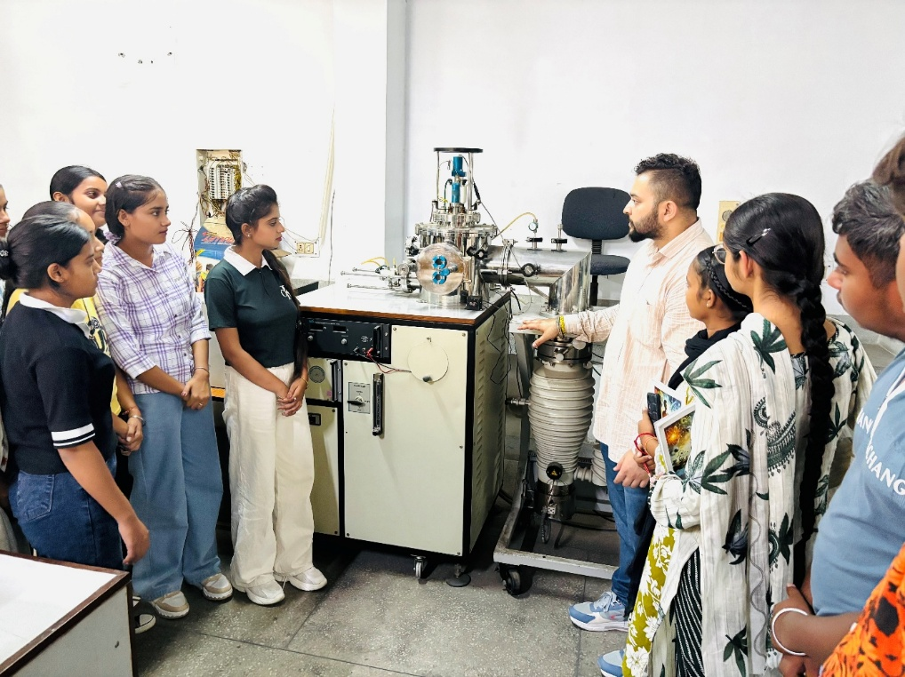
DEPARTMENT OF APPLIED SCIENCES AND HUMANITIES
Advanced Research Lab of Physics

The department has a series of fine and high-end research facilities to carry out advanced materials science experimental and theoretical research.

Following details of the instrumentation available in our research lab;

RF Sputtering System (Thin Film Deposition Facility)
The RF Sputtering System is a physical vapor deposition (PVD) unit utilized for growing high-purity, uniform thin films of insulating, dielectric, semiconductor, and conductive materials. By employing a high-frequency alternating radio frequency power source (13.56 MHz), this system prevents charge accumulation on non-conductive targets, allowing reliable deposition for advanced material research.
There are several more instruments which are listed below:
- Simultaneous Thermal Analyzer system (DTA/TGA/DSC)
- Thermobalance with TG-DTG-T Registration option DTA, 20 up to 1550° C
- Thermobalance basic unit
- Amplifier for balance
- Sample holder A1203
- DTA
- HDSC
- Crucible 0.3 ml
- Cap
- Protection tube A1203
- Furnace
- Thyristor Power unit 3.5 KVA
- Controller card
- Software basic module
- Win-Tw
- Multiplexer/Demultiplexer Training kit
- Advanced digital Transmitter/Receiver kit
- Fibre optics power meter
- Laser diode and glass fibre-based laser training kit
- Fibre optic connection kit
- HIOKI Model 3532-50 LCR Hi-Tester 42 Hz to 5 mHz
- 9262 Test Fixture Direction connection type
- Model 9700-10 Head Amp unit
- PICOAMMETER / Voltage source model 6487/E
- KUSB-488
- LOW NOISE TRIAX Cable model 237-ALG-2
- NBC Brand atmosphere-controlled tubular furnace
- Gas control unit
- Flang with O-ring
- C.S.T charge
- Double Beam PC Based UV-spectrophotometer UV 5704 S S
- Pentium-III PC with accessories for UV 570458
- Inverted metallurgical microscope without CCTV
- Micrometer WF 10
- Grain size eyepiece
- Grain size turret eyepiece
- Electronic Analytical Balance made in Germany, capacity 120 gm, accuracy 0.1mg, calib-internal
- Comparator 2000 Lovibono make
- Automatic low water level cut-off device
- Digital DO meter
- BOD incubator
- Interior illuminate
- Automatic timer
- Arrangement for incubation of CO₂
- CO₂ cylinder
- Air compressed
- Humidity control
- Distillation Apparatus
- Hydraulic Press
- Microprocessor-based programmable furnace max. temp 1400°C
- Gas Chromatograph model ultima 2100

